RESOLUTION NO.__________

RE: CERTIFICATE OF APPROPRIATENESS UNDER THE
PROVISIONS OF THE ACT OF THE PENNSYLVANIA
LEGISLATURE 1961, JUNE 13, P.L. 282 (53
SECTION 8004) AND BETHLEHEM ORDINANCE NO.
3952 AS AMENDED.

WHEREAS, it is proposed to replace the roof at 728 Evans St.

NOW, THEREFORE, BE IT RESOLVED by the Council of the City of Bethlehem that a Certificate of Appropriateness is hereby granted for the work.

Sponsored by: (s)

(s)

ADOPTED BY COUNCIL THIS DAY OF

(s)
President of Council

ATTEST:

(s)
City Clerk

HISTORIC CONSERVATION COMMISSION

CASE # 451 – It is proposed to replace the roof at 728 Evans St.
OWNER/APPLICANT: Results Homebuyers, Inc / Tom Rummel

The Commission upon motion by Mr. Roeder seconded by Mr. Evans adopted the proposal that City Council issue a Certificate of Appropriateness for the proposed work described herein:

- The proposal to replace the roof at 728 Evans St. was presented by Tom Rummel.

- The old, 3-tab black shingled roof may be replaced with GAF Architectural black shingles.

- This type of shingle is not generally recommended on houses that had slate originally, but because this house is located high above the sidewalk level and is close to the sidewalk the roof is not highly visible.

- The existing gutter is not to be replaced at this time.

- The proposed motion was unanimously approved.

CU: cu

By: 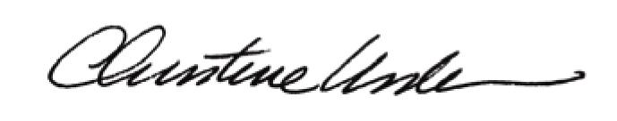

Date of Meeting: May 20, 2013 Title: Historic Officer

